## **POWER BI ANALYSIS**

# TASK 1

## DATA PREPARATION AND CLEANING

It involves extracting the datasets, transformingthem into a usable format,and addressing issues like duplicates, null values, and inconsistent column formats. This ensures clean and meainingful data for analysis.

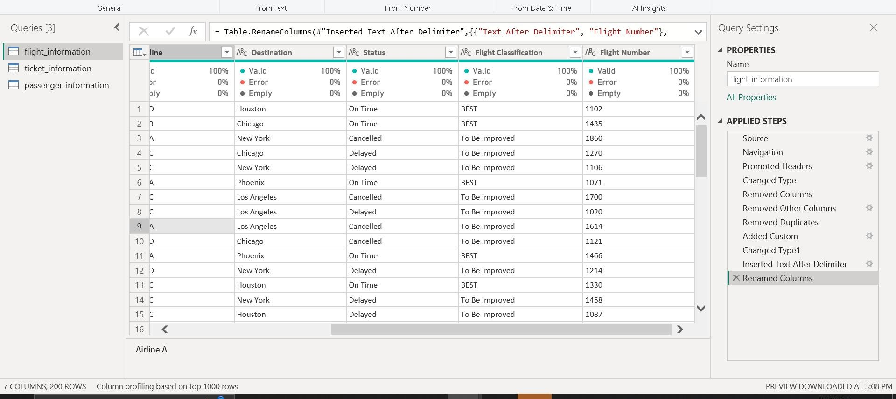

# TASK2

## DATA MODLING

It involves creating relationships between the datasets (e.g., linking FlightID across tables) and setting cardinality appropriately. This structure ensures seamless data integration for analysis.

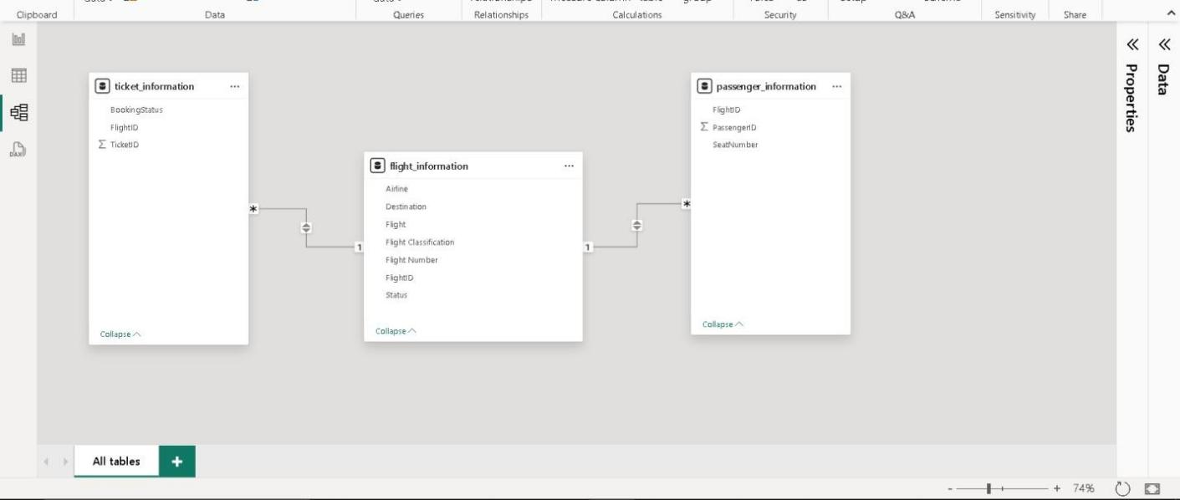

# TASH 3

## ENHANCED DATA INSIGHTS

Conditional columns Simplifies data understanding by deriving actionable columns based on status (e.g., "Best" or "To Be Improved") and highlights underperforming routes for targeted improvements.

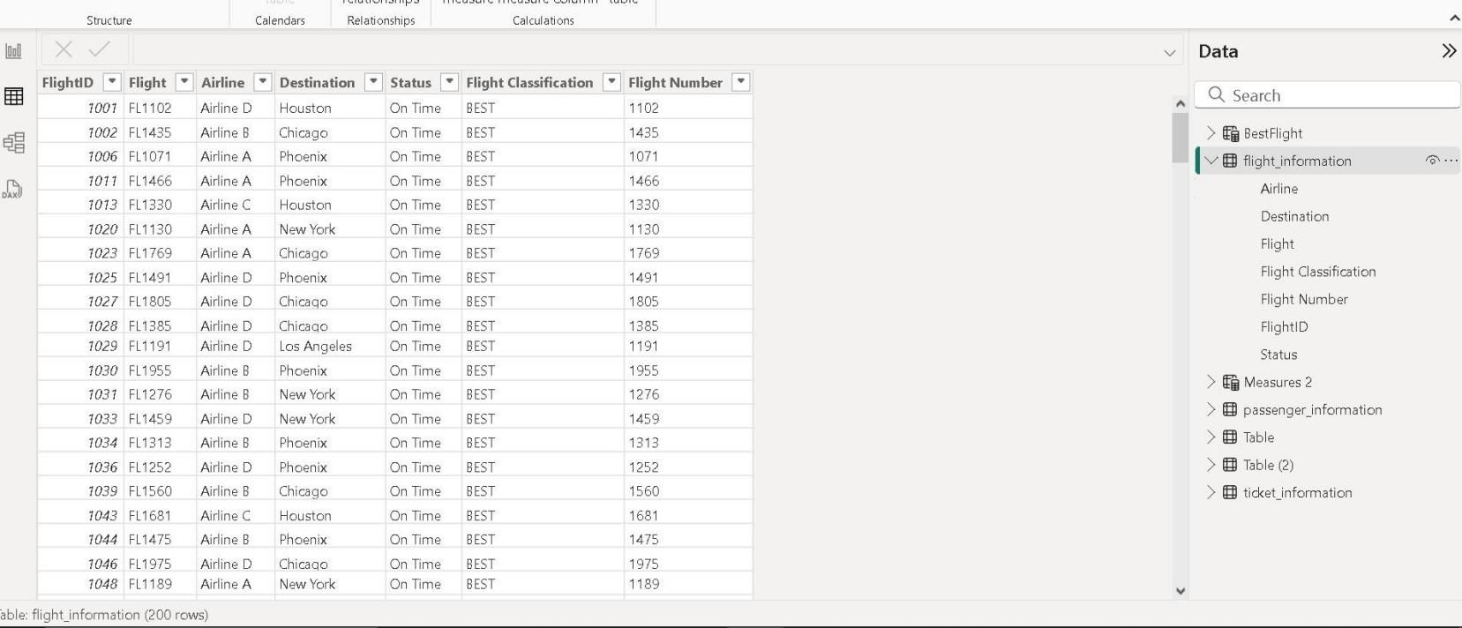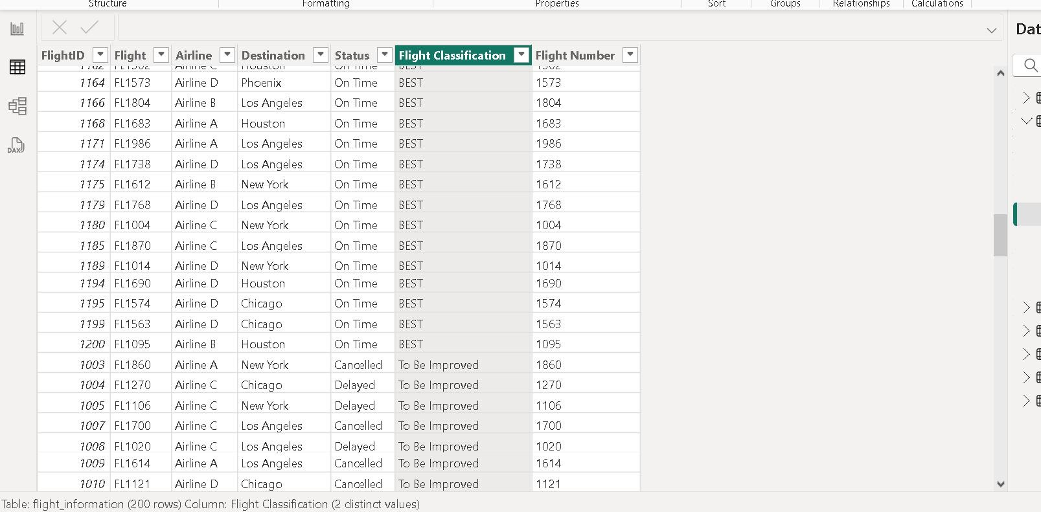



## TASK 4 CALCULATIONS USING DAX

DAX calculations compute metrics such as total passengers per flight, total tickets booked, and filtered tables for “Best” flights

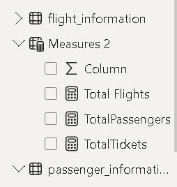

# Task 5

### VISULIZATION AND INTERACTIVE FEATURES

Visualizations display trends like passenger count by airline, ticket statuses, and flight destinations. Interactive features enable dynamic exploration of data by airline or destination.

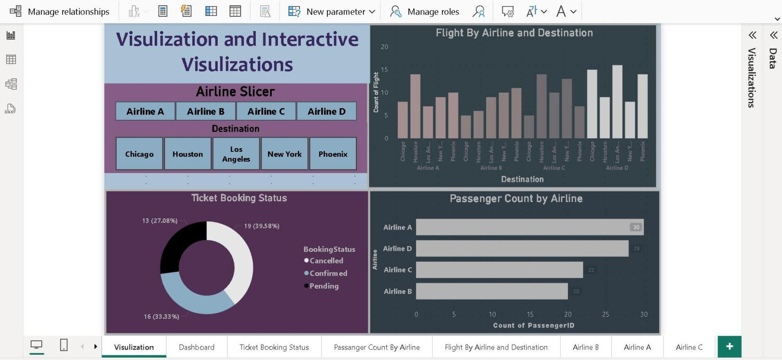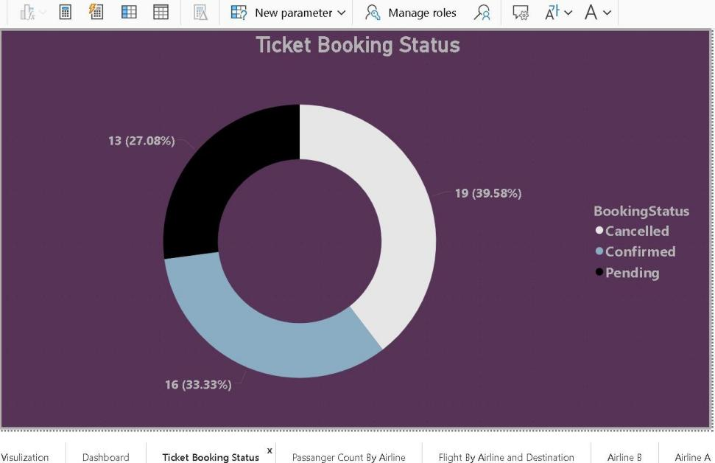

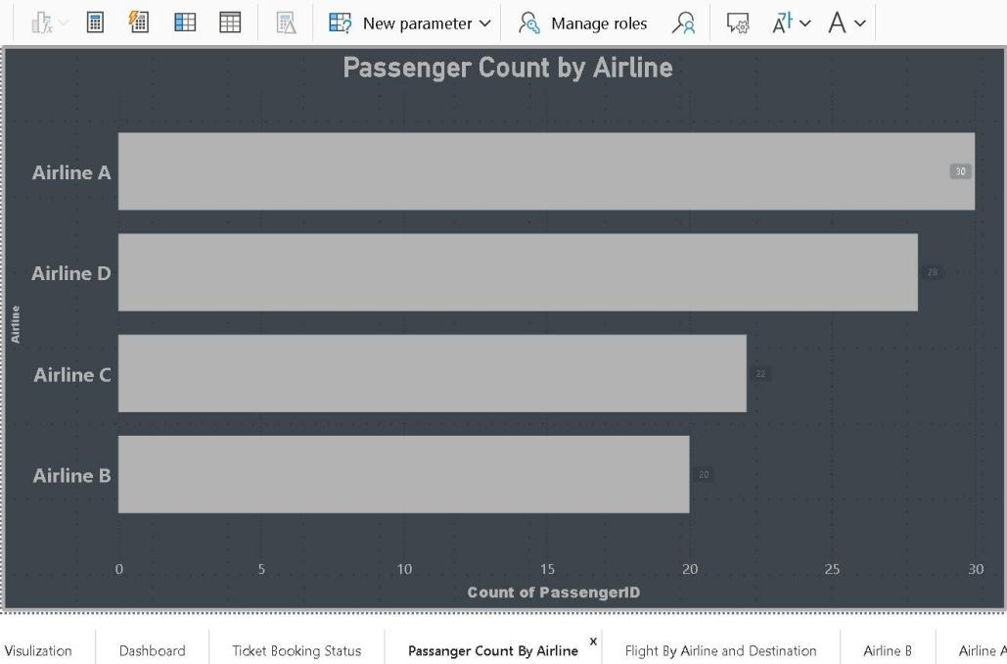

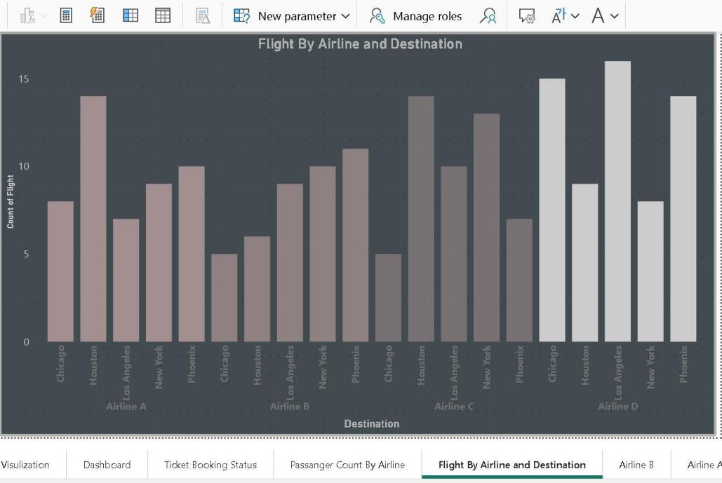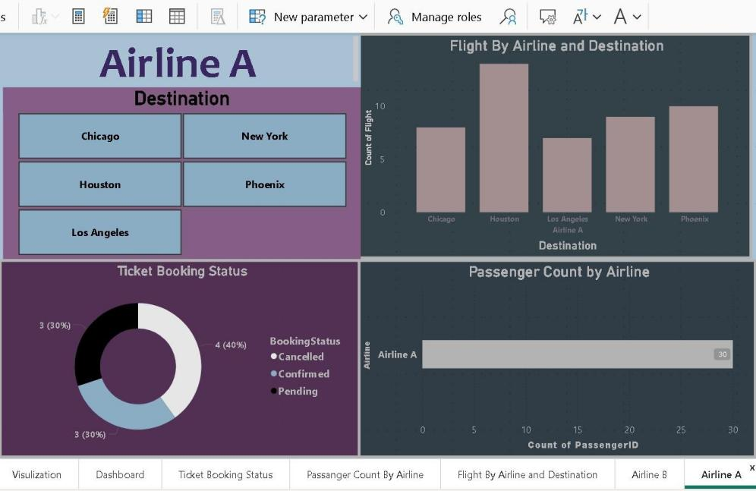

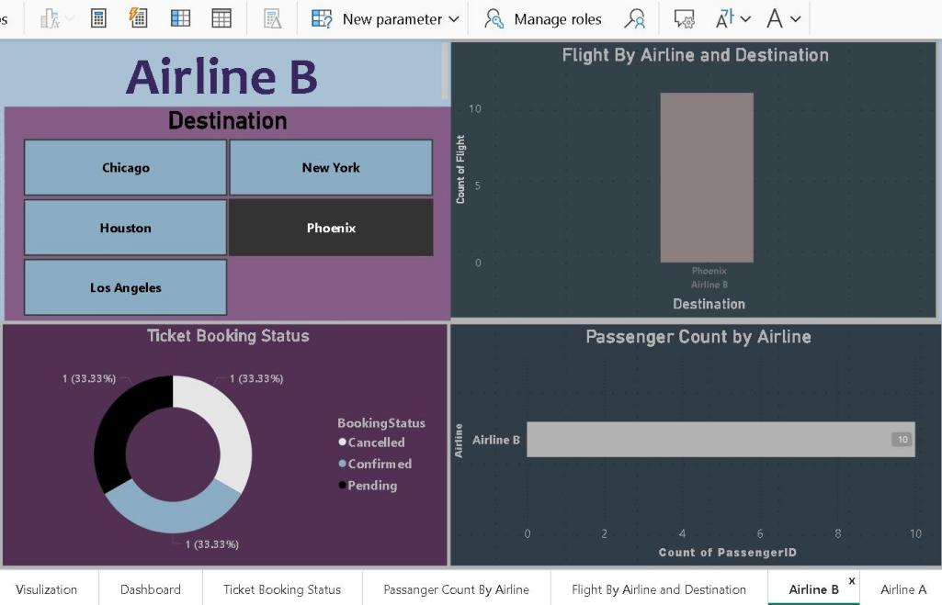

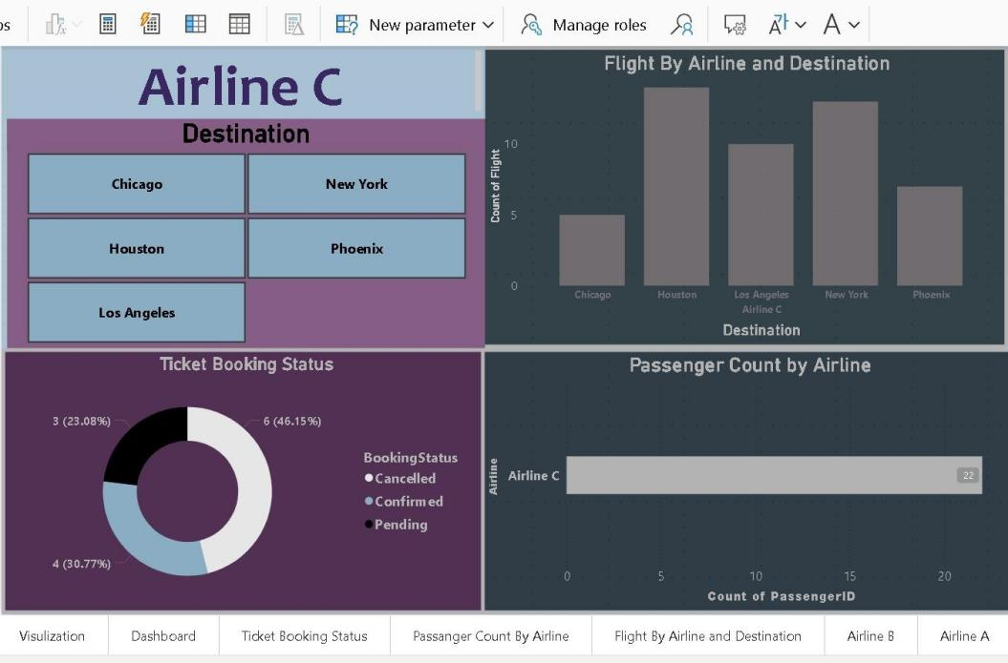

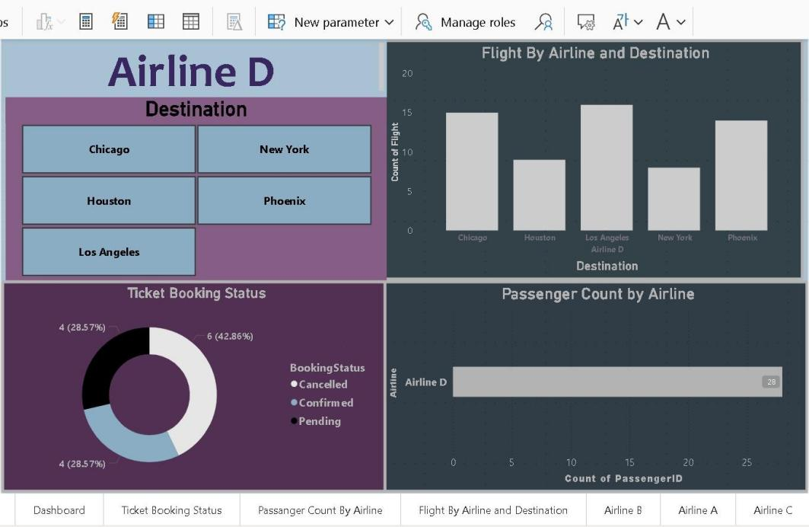

# TASH 6

### DASHBOARD

A dashboard consolidates key visuals for at-a-glance insights. Row-Level Security (RLS) ensures data confidentiality.

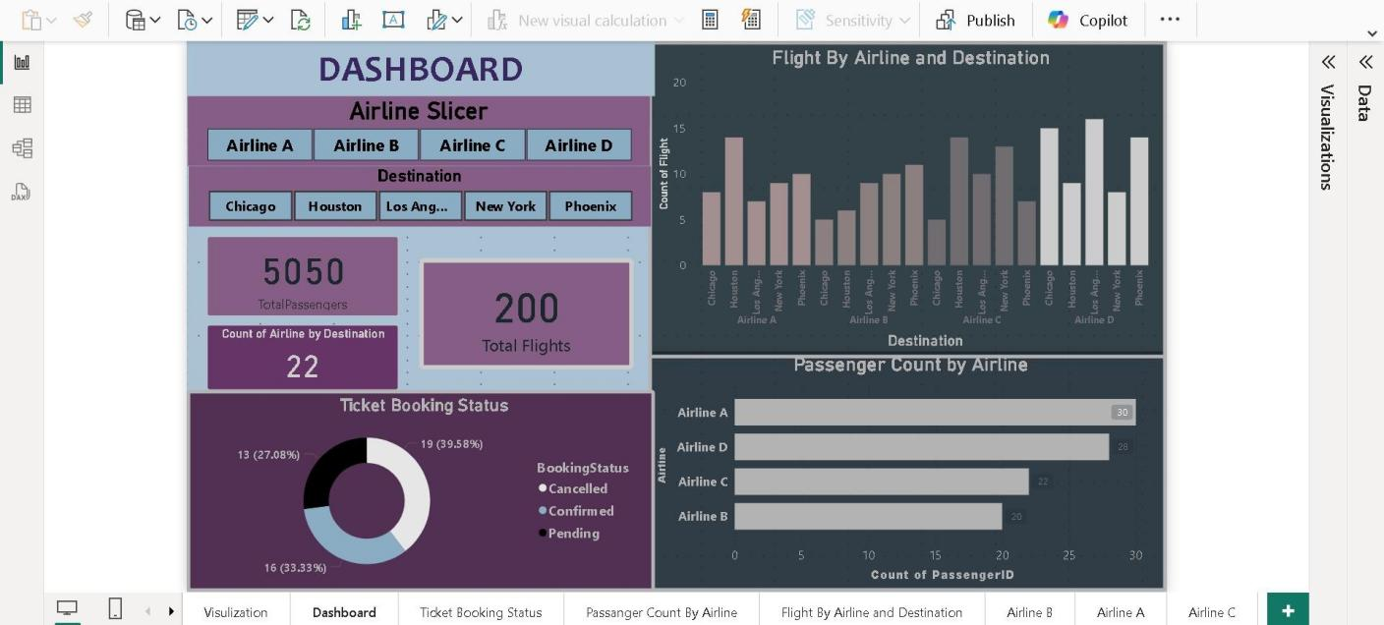

**ROW-LEVEL-SECURITY**

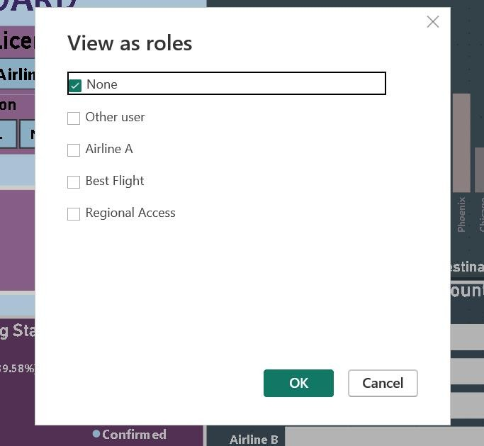

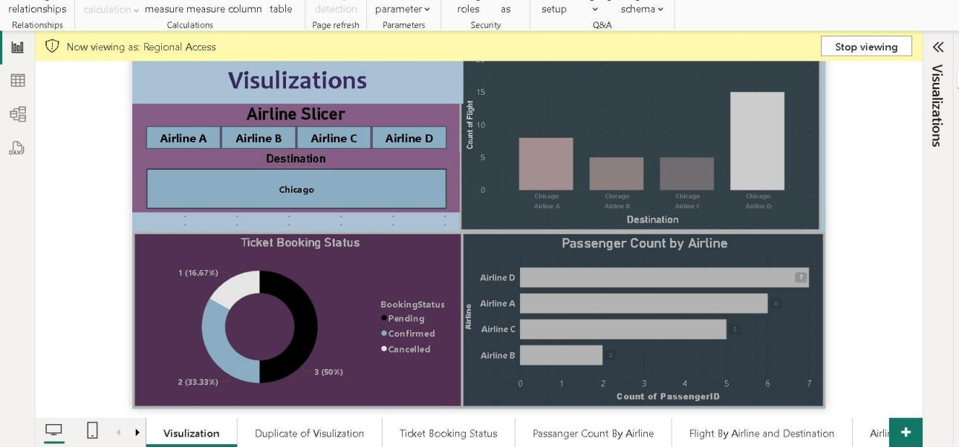

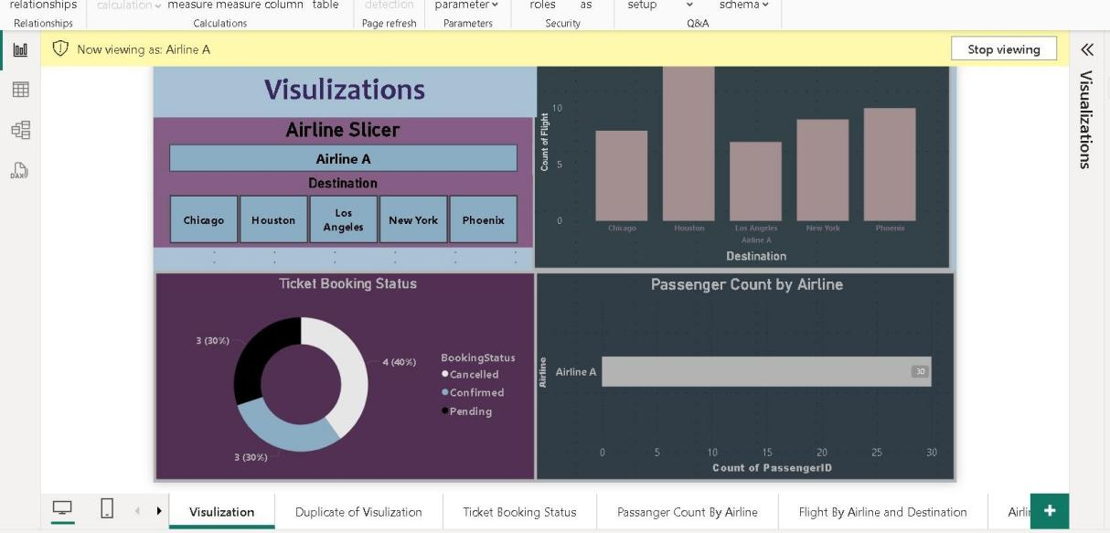

**Key Insights For Growth of Airline**

* By identifying "Best" flights, focus resources on replicating successful operational models across the network.
* Address gaps in underperforming routes with targeted changes like better scheduling or improved customer experience.
* Analysis of passenger counts enables optimized seat allocation and catering services.
* Insights into booking statuses reveal customer booking behavior, aiding in improved ticketing and promotions.
* Visualization of flights by destination and airline highlights high-demand routes, helping plan new destinations or increase flights on popular ones.
* Tracking ticket booking trends aids in dynamic pricing and promotional campaigns to boost bookings.
* Dashboards with real-time data provide decision-makers with actionable insights for continuous improvement and customer satisfaction.